**CALL CENTRE DATA ANALYSIS PROJECT**

### **Project Overview:**

Analysing Customers Data For A Call Centre To Gain Insights And Enhance Decision-Making.

### 

### **Project Objective:**

Generate A Improved Dynamic Dashboard’s For Call Centre Customers To Analyze And Visualize Customers Data.

### **Project Requirements:**

* Problem Statement
* Data Source
* Software’s Required

**Problem Statements:**

1. Overall customer satisfaction
2. Overall calls answered/abandoned
3. Calls by time
4. Average speed of answer
5. Agent’s performance quadrant -> average handle time (talk duration) vs calls answered
6. Define proper KPIs
7. Create a dashboard for the retention manager reflecting the KPIs

**Data Source:**

Utilizing Customers Data Collected By Call Centre For Comprehensive Data Analysis.

Data Collection Tool : MS excel

**Software’s Used:**

OS Tool : ChatGPT

BI Tool : Microsoft Power BI

### **Project Process:**

**Step By Step Process:**

1. Collecting the Data set
2. Importing Data set Into Power Bi
3. Data Transform And Cleaning
4. Data Processing(DAX)
5. Data Visualization
6. Final Dash Board

**1.Collecting Data**

The Data set collected From Call Centre In The Form Of Excel Sheets.

**2.Importing Data set Into Microsoft Power BI**

* For That, Open Power BI, Go to Get Data and Select Excel Workbook Then, Make a Connection With Excel File
* After Completion of Connection we can Load Or Transform Data Based On Requirement

**3,4.Data Cleaning &Processing**

* After Loading Data Into PowerBI By Using The Power Query Editor, We Perform DAX(Data Analysis Express) For Data cleaning and Processing
* These Are Some Of DAX Formulas written for Data Visualization

**DAX Formula’s:**

**1.Date Table**

Date Table = CALENDAR(MIN('Call Centre Data'[Date]),MAX('Call Centre Data'[Date]))

Hour Table = VAR StartingHour = 0 VAR EndingHour = 23

RETURN GENERATESERIES(StartingHour, EndingHour)

**2.Customers Data table**

1. Total Calls Answered = CALCULATE(COUNTROWS('Call Centre Data'),'Call Centre Data'[Answered (Y/N)]= "Y")
2. Avg Satisfaction = AVERAGE('Call Centre Data'[Satisfaction rating])
3. Overall Calls Answered = COUNTROWS(FILTER('Call Centre Data','Call Centre Data'[Answered (Y/N)]="Y"))
4. Overall Calls Abandoned = COUNTROWS(FILTER('Call Centre Data','Call Centre Data'[Answered (Y/N)]="N"))
5. Overall customer satisfaction = VAR _countpositive =CALCULATE(DISTINCTCOUNT('Call Centre Data'[Call Id]),FILTER('Call Centre Data','Call Centre Data'[Satisfaction rating] <> BLANK()))VAR _counttotal=CALCULATE(DISTINCTCOUNT('Call Centre Data'[Call Id]))

RETURN

DIVIDE(_countpositive,_counttotal)

1. Average Handle Time = AVERAGEX(FILTER('Call Centre Data', 'Call Centre Data'[Answered (Y/N)] = "Y")'Call Centre Data'[AvgTalkDuration])
2. Average Speed of Answer = AVERAGEX(FILTER('Call Centre Data','Call Centre Data'[Answered (Y/N)] = "Y")'Call Centre Data'[Speed of answer in seconds])
3. CallsByHour = COUNTROWS(FILTER('Call Centre Data',HOUR('Call Centre Data'[Time]) = VALUE(FORMAT(NOW(), "HH")) ))
4. CallsByTime = COUNTROWS('Call Centre Data')

**3.Churn Data Table**

1. Total No Of Customers = COUNT('01 Churn-Dataset'[customerID])
2. Total Tenure = SUM('01 Churn-Dataset'[tenure])
3. Total Charges = SUM('01 Churn-Dataset'[TotalCharges])
4. Tech Tickets Count = SUM('01 Churn-Dataset'[numTechTickets])
5. Tech support yes = CALCULATE(COUNTROWS(FILTER('01 Churn-Dataset','01 Churn-Dataset'[TechSupport]="Yes")))
6. Streaming TV yes = CALCULATE(COUNTROWS(FILTER('01 Churn-Dataset','01 Churn-Dataset'[StreamingTV]="Yes")))
7. Streaming Movies yes = CALCULATE(COUNTROWS(FILTER('01 Churn-Dataset','01 Churn-Dataset'[StreamingMovies]="Yes")))
8. Phone service yes = CALCULATE(COUNTROWS(FILTER('01 Churn-Dataset','01 Churn-Dataset'[PhoneService]="Yes")))
9. Phone Service Rate = DIVIDE([Phone service yes],[Total No Of Customers])
10. Phone service No = CALCULATE(COUNTROWS(FILTER('01 Churn-Dataset','01 Churn-Dataset'[PhoneService]="No")))
11. Parters Count = CALCULATE(COUNTROWS(FILTER('01 Churn-Dataset','01 Churn-Dataset'[Partner] = "Yes")))
12. Online Security yes = CALCULATE(COUNTROWS(FILTER('01 Churn-Dataset','01 Churn-Dataset'[OnlineSecurity]="Yes")))
13. Online Backup yes = CALCULATE(COUNTROWS(FILTER('01 Churn-Dataset','01 Churn-Dataset'[OnlineBackup]="Yes")))
14. No Of Senior Citizens = CALCULATE(COUNTROWS(FILTER('01 Churn-Dataset','01 Churn-Dataset'[SeniorCitizen]="1")))
15. No Of Churn Customers = CALCULATE(COUNTROWS(FILTER('01 Churn-Dataset','01 Churn-Dataset'[Churn]="YES")))
16. Multilines Yes = CALCULATE(COUNTROWS(FILTER('01 Churn-Dataset','01 Churn-Dataset'[MultipleLines]="Yes")))
17. Multilines Rate = DIVIDE([Multilines Yes],[Total No Of Customers])
18. Multilines No Phone service = CALCULATE(COUNTROWS(FILTER('01 Churn-Dataset','01 Churn-Dataset'[MultipleLines]="No Phone Service")))
19. Multilines No = CALCULATE(COUNTROWS(FILTER('01 Churn-Dataset','01 Churn-Dataset'[MultipleLines]="No")))
20. Monthly Charges = SUM('01 Churn-Dataset'[MonthlyCharges])
21. Internet Service No = CALCULATE(COUNTROWS(FILTER('01 Churn-Dataset','01 Churn-Dataset'[InternetService]="No")))
22. Internet Service Fiber Optic = CALCULATE(COUNTROWS(FILTER('01 Churn-Dataset','01 Churn-Dataset'[InternetService]="Fiber Optic")))
23. Internet Service DSL = CALCULATE(COUNTROWS(FILTER('01 Churn-Dataset','01 Churn-Dataset'[InternetService]="DSL")))
24. Fiber Optic Internet Rate = DIVIDE([Internet Service Fiber Optic],[Total No Of Customers])
25. DSL Internet Rate = DIVIDE([Internet Service DSL],[Total No Of Customers])
26. Device Protection Yes = CALCULATE(COUNTROWS(FILTER('01 Churn-Dataset','01 Churn-Dataset'[DeviceProtection]="Yes")))
27. Dependents' Count = CALCULATE(COUNTROWS(FILTER('01 Churn-Dataset','01 Churn-Dataset'[Dependents] = "Yes")))
28. Customer Tenure = DIVIDE([Total Tenure],[Total No Of Customers])
29. Churn Rate = DIVIDE([No Of Churn Customers],[Total No Of Customers])
30. Avg Monthly Charges = DIVIDE([Monthly Charges],[Total No Of Customers])
31. Avg Charges Per Customer = DIVIDE([Total Charges],[Total No Of Customers])
32. Admin Tickets Count = SUM('01 Churn-Dataset'[numAdminTickets])
33. % Tech Support = DIVIDE([Tech support yes],[Total No Of Customers])
34. % Streaming TV = DIVIDE([Streaming TV yes],[Total No Of Customers])
35. % Streaming Movies = DIVIDE([Streaming Movies yes],[Total No Of Customers])
36. % Senior Citizens = DIVIDE([No Of Senior Citizens],[Total No Of Customers])
37. % Partners = DIVIDE([Parters Count],[Total No Of Customers])
38. % Online Security = DIVIDE([Online Security yes],[Total No Of Customers])
39. % Online Backup = DIVIDE([Online Backup yes],[Total No Of Customers])
40. % Device Protection = DIVIDE([Device Protection Yes],[Total No Of Customers])
41. % Dependents = DIVIDE([Dependents' Count],[Total No Of Customers])
42. Multi Lines = {("Multilines Yes", NAMEOF('Calculations'[Multilines Yes]), 1),("Multilines No", NAMEOF('Calculations'[Multilines No]), 0)}
43. Parameter = {("DSL Internet Rate", NAMEOF('Calculations'[DSL Internet Rate]), 0), ("Fiber Optic Internet Rate", NAMEOF('Calculations'[Fiber Optic Internet Rate]), 1),("Multilines Rate", NAMEOF('Calculations'[Multilines Rate]), 2),("Phone Service Rate", NAMEOF('Calculations'[Phone Service Rate]), 3)}

**5.Data Visualization**

* After Cleaning And Processing The Data According To The Requirements of Call Centre, Prepare Dashboards’ For A Call Centre To Get Insights And Improve Decision-Making

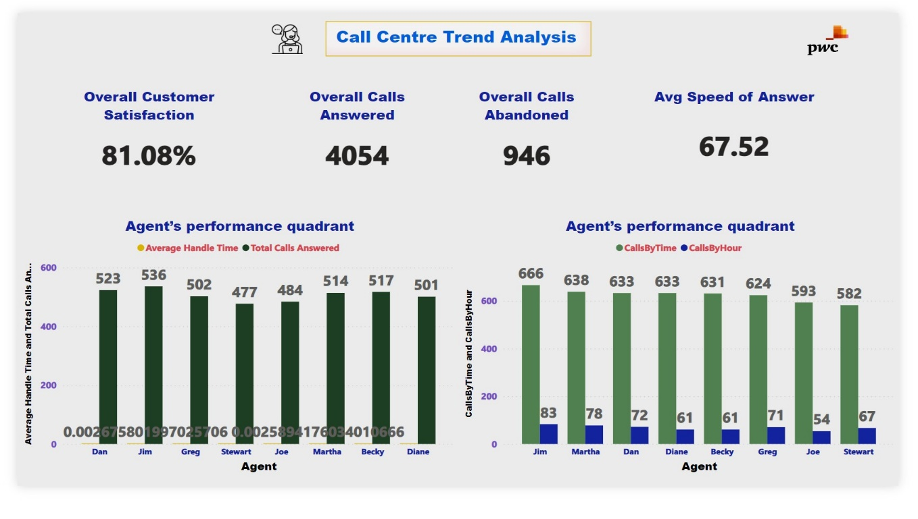

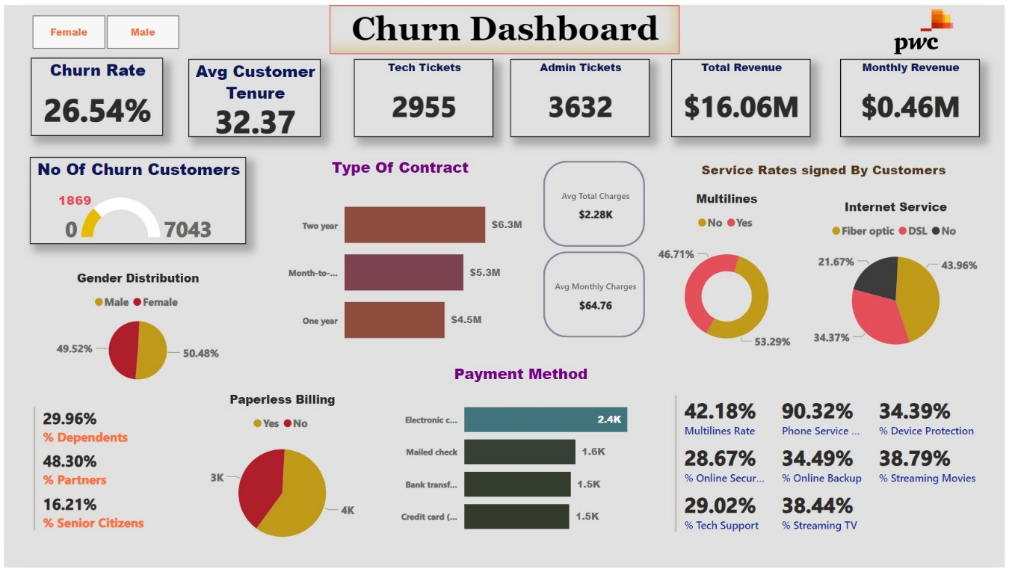

### **Conclusion:**

**For Call Centre Trend Analysis Dashboard**

**Customer Satisfaction**:

The overall customer satisfaction rate is quite high at **81.08%.**

**Call Volume:**

* A total of **4054 calls** were answered, while **946 calls** were abandoned, indicating a need to possibly improve response times or staffing to reduce abandoned calls.

**Response Efficiency:**

* The average speed of answer is **67.52 seconds**, which could be optimized for better customer experience.

**Agent Performance:**

* There is a variation in agents’ performance with respect to average handle time and total calls answered. Strategies could be implemented to improve efficiency across all agents.

**Calls per Hour**:

* The efficiency of calls per time to calls per hour varies among agents, suggesting that some may require additional training or support.

**For Churn Dashboard**

**Churn Rate:**

* The company is experiencing a churn rate of **26.54%**, which is quite significant.

**Customer Demographics:**

* There is a higher churn among male customers, indicating a possible area to investigate for targeted retention strategies.

**Customer Tenure:**

* The average customer tenure is **32.37 months**, suggesting moderate loyalty but also room for improvement in long-term retention.

**Support Tickets:**

* A considerable number of tech and admin support tickets have been raised, which could be indicative of service issues affecting customer satisfaction.

**Revenue Analysis:**

* The total revenue stands at **$16.06M**, with a monthly contribution of **$0.46M** from PWC, highlighting the revenue impact of churn.

**Contract Preferences:**

* Most customers prefer month-to-month contracts with paperless billing and electronic payments, which could influence the development of tailored service packages.

**Service Utilization:**

* Many customers do not opt for additional services like online security or tech support, which presents an opportunity to upsell these services.